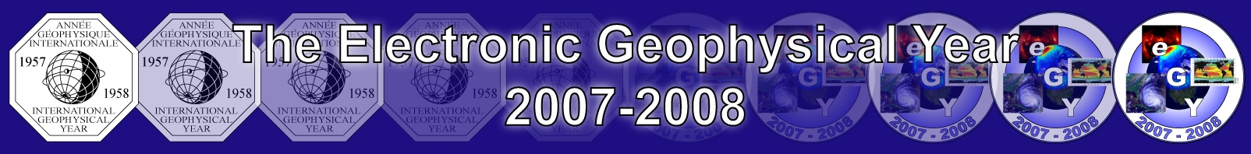

50 Years after IGY



“e-Science for Geoscience”

Participate in eGY

Use 2007-2008 for a coordinated
international effort to improve

- access to data and information
(Virtual Observatories)
- data integration and knowledge discovery
- data release
- data discovery
- data rescue and preservation
- outreach and public education
- reducing the digital divide.

www.egy.org

Email: Bill.Peterson@lasp.colorado.edu

