

www.egy.org

International Council of Science (ICSU)
Committee on Data for Science and Technology (CODATA)

20th CODATA Meeting (Beijing China)

“Scientific Data and Knowledge within the Information Society”

MINUTES FROM THE CODATA WORKSHOP – 25 OCTOBER 2006

"The New Frontier in Defining the Data to Knowledge Paradigm"

PARTICIPANTS:

Bob Chen | bchen@ciesin.columbia.edu
Shinichi Watari | watari@nict.gojp
Rui Jin | jihrui@lab.ac.cn
Xin Li | lixin@lab.ac.cn
Youhua Ran | ranyh@lab.ac.cn
Marcel Endejan | marcel.endejan@uni-bonn.de
Rainer Peoershake | rainer.poerschake@springer.com
Susan McLean | susan.mclean@noaa.gov
Bill Peterson | bill.Peterson@lasp.colorado.edu
Yinlan Li | yulangeat@hotmail.com
Xinxing Liang | lianxinxing507@sohu.com
Lizong Wu | wulizong@lzb.ac.cn
Ali Erdi | aerdi@selcuk.edu.tr
Zhuotong Nan | nztong@lab.ac.cn
Peng Fenglin | pengf@ustc.edu
Eric Kihn | eric.a.kihn@noaa.gov
Peter Fox | pfox@ucar.edu
Paolo Pumilia | paolo.pumilia@acm.org
Michail Zhizhin | jjn@wdcb.zu
Jie Liang | ucgn@sohme.com
Rie Honda | Honda@is.kochi-u.ac.jp
Liping Di | ldi@gmu.edu
Meixia Deng | mdeng@gmu.edu
Ken McDonald | ken.mcdonald@nasa.gov
Ken T. Murata | murata@cite.chime-u.ac.jp
Charles Barton | charles.barton@anu.edu.au
Toshihiko Iyemori | iyemori@kugi.kyoto-u.ac.jp
Alex Sterin | sterin@meteo.ru
Liu Chuang | lchuang@igsnrr.ac.cn
Mark Parsons | parsonsm@nsidc.org
David Clark | David.M.Clark@noaa.gov
Paul Berkman | paul@evresearch.com berkman@bren.ucsb.edu

SCOPE OF THE WORKSHOP:

The abstract and background materials that were distributed for this workshop can be found in Appendix 1 and Appendix 2, respectively. The goal of this workshop was to begin planning an international experiment that integrates Earth system data from at least two highly disparate data centers (one of which may be a World Data Center). The experiment would:

- Enable data from centralized repositories to be dynamically and objectively integrated;

- Derive meaningful relationships within and between data resources; and

- Facilitate the discovery of knowledge to address a well-defined Earth system problem.

Potential Phases of the Knowledge Discovery Experiment:

- Demonstrate that metadata can be re-purposed in an interoperable manner

- Use re-purposed metadata to identify relationships between datasets

- Link re-purposed metadata to actual datasets in relational contexts

- Enhance granularity of datasets directly to interpret objective relationships within and between datasets

- Elaborate the process to adjust the granularity for additional interpretations

Phase 1 of the Knowledge Discovery Experiment:

Objective: Demonstrate interoperability and value added of metadata that has been re-purposed with automated granularity.

Experimental Design: The metadata and associated digital objects would be selected based on a specific experimental framework associated with GEO-GEOSS societal benefit areas (i.e., disasters, health, energy, climate, water, weather, ecosystems, agriculture or biodiversity – see http://www.earthobservations.org/progress/societal_benefits/societal_benefits.html).

Experimental Methods: Utilize general structural features of metadata (e.g., colon ":" as a boundary condition / rule set) as well as common elements to automate the granularity for dynamically relating elements within and between metadata records

INTRODUCTORY COMMENTS:

Introductory powerpoint slides from Paul Berkman were adapted from:

Berkman, P.A., Morgan, G.J., Moore, R. and Hamidzadeh, B. 2006a. Automated Granularity to Integrate Digital Information: The “Antarctic Treaty Searchable Database” Case Study. Data Science Journal, Volume 5, Pages 84-99.
(http://www.jstage.jst.go.jp/article/dsj/5/0/84/_pdf)

Berkman, P.A., Morgan, G.J., Moore, R. and Hamidzadeh, B. 2006b. Automated Granularity to Integrate Digital Information: The “Antarctic Treaty Searchable Database” Case Study. Data Science Journal, Volume 5, Pages 84-99.(Spanish Translation). Archivo Municipal, Cartagena, Spain.
(http://archivo.cartagena.es/recursos/texto0_antarctica_dos.pdf)

Distinctions between information access and integration underlie technological solutions for the future when “knowledge is the common wealth of humanity”, as expressed by His Excellency Adama Samassekou at the 2004 CODATA meeting in Berlin. To assess the challenges with the digital medium, it is instructive to take a broad view of written communications in our civilization. From stone and clay to paper onto digital media, each era has increased our capacity to transport, produce and integrate information (Fig. 1).

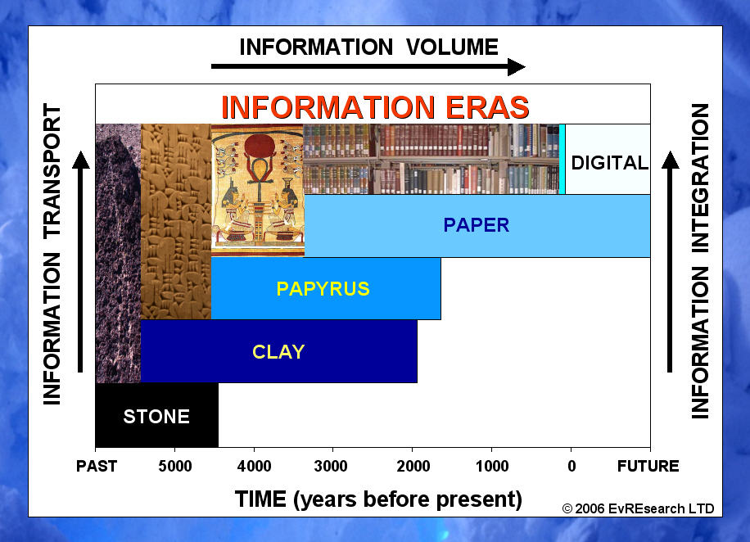

FIGURE 1: Thresholds in the creation, management and discovery of written information in our civilization. Each of the media prior to digital had been used for millennia. From stone to digital media: (a) the transport of information across time and space has increased; (b) the volume and rate of information produced has increased; and (c) the capacity to integrate information into new knowledge has increased. From Berkman et al. (2006a,b).
For example, the Internet has been evolving since the late 1960’s with the number of Internet hosts increasing from 213 in 1981 to over 350,000,000 in 2005. Since 1972, microprocessor speeds have increased 5 orders of magnitude while satellite systems have made it possible to collect and transmit information on a global scale. Moreover, the volume of digital information doubled in the three years after 1999 with more than 5 exabytes (10¹⁸ bytes) of information stored on print, optical and magnetic in 2002 alone. We also have powerful search engines to retrieve digital information from vast warehouses. These features all point to the observation that access to digital information has become effectively infinite and instantaneous.

Information has three indivisible elements – content, context and structure – that together provide meaning (Fig. 2).

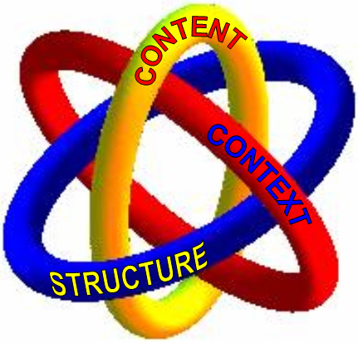

FIGURE 2: “Borromean rings of meaning” that illustrate the three indivisible elements of information that together provide meaning. From Berkman et al. (2006 a,b).

For example, when a message is encrypted (i.e., the structure is altered) it still has content and context, but no meaning. Similarly, if the names or dates and places are removed from an information resource, it still has context and structure, but limited meaning without the salient facts. Removing context features that can be used to authenticate an information resource also will compromise its meaning.

The paradigm shift created by digital technologies is the opportunity to utilize the structure of information as well as its content and context. A printed book can be managed based on its content (as in libraries) or its context (as in archives), but it is not possible to break a book into smaller units that can be managed automatically. It is this ability to automatically manipulate the granularity of information resources that distinguishes digital media from all of the hardcopy predecessors that have been applied throughout human civilization (Fig. 1).

The potential to discover meaningful relationships within and between the information resources is directly proportional to their granularity. For example, for a given search query, two books could generate 4 possible results (i.e., one book or the other, both books together, neither of the books). If each book were divided into two granules, there would be 16 possible combinations with 0, 1, 2, 3 or 4 granules. If each book were divided into four granules (i.e., 8 total), there would be 256 possible combinations with 0 to 8 granules. Consequently, among N granules there are 2^{N} possible relationships. Being able to express and then decompose the ternary, quaternary and higher-order relationships may reveal functional dependencies among the granules.

Despite the opportunity to utilize the inherent structure of digital information, knowledge discovery with digital information is largely facilitated in relation to its content, as with descriptive and administrative metadata. With regard to descriptive metadata, there is an expanding universe of schema for different disciplines, institutions and activities (e.g., http://www.mapageweb.umontreal.ca/turner/meta/english/) that each contains different sets of attributes (e.g., name, size, data type, use restrictions, etc.) that must be defined or documented with specified nomenclatures for every digital object. More importantly, metadata does not scale, which is a principal reason behind the widely-held notion that there is “structured” and “unstructured” information (rather than information that is “managed” and “unmanaged” with conventional technologies).

A simple experiment can be constructed to illustrate the scalability limitations of metadata (Fig. 3). Consider a book that that has a volume of 20 (in arbitrary units) and that each completed metadata schema has a volume of 1 (in arbitrary units). If the book is divided into two granules, each of which must have its own metadata schema, then the total volume of the book remains constant while the total volume of metadata schema has doubled. If the granularity is continuously doubled, the volume of metadata soon will overwhelm the volume of the actual data that is being managed. The additional metadata also requires increased effort to generate, store and process – which translates into costs and efficiencies. Moreover, if the metadata is stored in separate repositories, then loss of the metadata could compromise the preservation of the actual data.

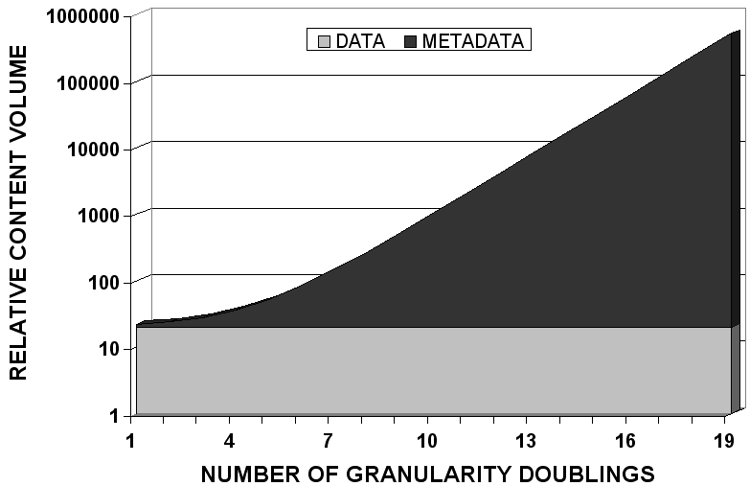

FIGURE 3: A simple model to illustrate the exponentially increasing volume of metadata, as the granularity is doubled, relative to the actual data within a single digital resource. In this model, the total volume of all information granules is constant (arbitrarily 20 units) and total volume of the metadata schema for each granule is fixed (arbitrarily 1 unit) independent of granule size. From Berkman et al. (2006a,b).

Summary:

The rationale for the Phase 1 of the Knowledge Discovery Experiment (see above):

- Metadata is ubiquitous;
- Metadata contains descriptions of content and context;
- Metadata requires significant and ever-increasing effort to produce and manage; and
- Metadata is designed to facilitate access rather than discovery of relationships.

NOTES FROM THE WORKSHOP DISCUSSION:

The following concept map was crafted and introduced by David Clark to frame the workshop discussion (Fig. 4).

FIGURE 4: Schematic to stimulate discussion about Phase 1 of the Knowledge discovery Experiment (see above) to re-purpose metadata from the Committee on Earth Observation Satellites (CEOS) / Working Group on Information Systems Services (WGISS) / WGISS Test Facility for Coordinated Enhanced Observing Period (WTF-CEOP). See Appendix 2.

- Consider WTF-CEOP MOLTS and gridded data
  - http://www.eol.ucar.edu/projects/ceop/dm/model/ukmo/UKMO_notes_on_data.doc

- Necessary to consider the quality of the metadata in the experiment
  - Metadata alone is not sufficient to address societal issues
  - Potential relationships among metadata elements should be quantified with the underlying data

- Possible societal issues
  - Relate land cover vs. land use

- Generate granule level metadata (e.g., time, spatial coverage, events, etc.)

- Retrieve data across a selection of fields
  - Create a time series

- Identify a manual process associated with metadata and create an automated solution

- There are many taxonomies that the international community have to work with, is this a possible focus area?

- Land Use/Land Cover discrimination is big problem, (a remote sensing - land application), and there are social science aspects to this also. This could involve both disciplines in this project. --- Possible good project.

- Metadata may not really hold information; the information is in the data. (NOTE: I don’t think I agree with this statement.)

- Working with Net CDF might be a possible candidate for the experiment. NCAR has many directories with non-standard files. How to aggregate these into something useful (see: Peter Fox, NCAR).

      - ISO 19115 – working with this is also a good idea because it is an international standard.

      - Change our chart. It should really be data→Information→knowledge→wisdom

      - Water could be a very important topic – Prof. Xin Li from the WDC in Lanzhou wants to be a partner in the experiment.

      - Possible partners and projects
        - Land cover/Land use discrimination
        - Water – water resources
        - Air Quality
        - Dust Storms
        - Russian Geophysical Center
        - WDC Lanzhou
        - Microsoft Escience initiative
        - NCAR
        - CIESIN
        - NSIDC
        - WTF CEOP – (note, I will be going to the WGISS meeting in Vietnam in May 2007 where the WTF CEOP and the CEOP folks will be in attendance.)

          - Can’t define problem first – maybe we need to look at relationships first to see what you can get out of the relationships. Then look at the results and frame a response to an issue or problem. The group seemed to think we were putting the cart before the horse. So, maybe we need to rethink the experiment a bit before we actually start. .

          - Peter Fox – issue: how data sets and data centers characterize their capabilities and how to show? NCAR and NSIDC would be good candidates for this.

          - “To extract information you need to know the semantics.”

APPENDIX 1

ABSTRACT FOR THE CODATA WORKSHOP

"The New Frontier in Defining the Data to Knowledge Paradigm"

Presentation : First thoughts on the experiment: Paul Berkman
Conveners: Paul Berkman, Dave Clark, Mark Parsons and Liu Chuang

In 1957-58, the International Geophysical Year launched an era of international and interdisciplinary research on the Earth system. In addition to developing the first comprehensive look at the Earth system, among the other significant achievements was the establishment of the World Data Center system and the first artificial satellites in orbit. Today, we are being overwhelmed by the volume of digital information and diverse strategies for its management. Needs are becoming acute to share diverse digital data across boundaries, particularly when 15% of the digital information is considered to be structured and the remaining 85% is unstructured for the purposes of knowledge discovery. Like the first satellites, which just demonstrated the potential for planetary observing systems with diverse payloads, dynamically integrating data and discovering knowledge from disparate data centers would be a demonstration of capacity.

This workshop will begin planning an international experiment with data from at least two highly disparate data centers (one of which is a World Data Center). The experiment will be designed to: (a) dynamically, comprehensively and objectively integrate these data; (b) derive meaningful relationships from the data; and (c) generate knowledge to address a well-defined Earth system science problem. The problem will be related to the Polar Regions, in recognition of the International Polar Year that will be convened from March 2007 to March 2009. To successfully design this international and interdisciplinary data experiment, we will need input from data managers, software engineers, metadata experts, Earth scientists and other individuals involved with data preservation, access and analysis.

This workshop will be convened as a panel with active audience participation. The panel members will include individuals from the CODATA sessions on: Steps Towards a System of Systems; Best Practices; Virtual Observatories in the Geosciences; and Data Mining, Data Integration and Knowledge Discovery. This workshop is a product of discussions from the International Polar Year (http://www.ipy.org) and Electronic Geophysical Year (http://www.egy.org) programs. Paul Berkman will serve as the panel moderator.

APPENDIX 2

ADDITIONAL NOTES POSTED BY CODATA BEFORE THE WORKSHOP
(http://www.codataweb.org/06conf/abstracts/L1/index.htm)

We have had preliminary discussions with the Committee on Earth Observation Satellites (CEOS) / Working Group on Information Systems Services (WGISS) / WGISS Test Facility for Coordinated Enhanced Observing Period (WTF-CEOP) to apply the knowledge-discovery experiment to WTF-CEOP metadata. WTF-CEOP is a prototype distributed data integration system with in-situ, satellite and numerical-weather-prediction model output data.

Based on our discussions, the WTF-CEOP metadata (e.g., Fig. 5) could provide the nucleus for implementing the knowledge discovery experiment that is being introduced in coordination with the Electronic Geophysical Year and International Polar Year. There is societal relevance and a good rationale for working with WTF-CEOP with regard to the health, biodiversity and agricultural societal benefit areas that are elaborated by the Group on Earth Observations - Global Earth Observation System of Systems (http://www.earthobservations.org/progress/societal_benefits/societal_benefits.html). To apply the experiment to WTF-CEOP metadata, we will need granule level (rather than collection level) descriptions. The opportunity with digital resources is to utilize their inherent structure and patterns to implement granule-level descriptions in an automated manner that will dynamically identify objective relationships within and between resources. "Automated granularity" (see http://www.jstage.jst.go.jp/article/dsj/5/0/84/_pdf):

- utilizes the inherent structure of digital records;

- applies the context of the parent resource to each of its children without additional metadata descriptions for each granule separately;

- defines the unique position (e.g., header tag with hierarchal information) of each granule relative to its parent resource;

- indexes the content of each granule so that it can be searched, displayed, retrieved and analyzed in relation to all other relevant granules; and

- provides an interoperable solution to go beyond access, which is generally represented in terms of lists that hide relationships within and between information resources.

In the CODATA workshop, we will discuss:

Potential Phases of the Experiment

- Demonstrate that metadata can be repurposed in an interoperable manner
- Use repurposed metadata to identify relationships between datasets
- Link repurposed metadata to actual datasets in relational contexts
- Enhance granularity of datasets directly to interpret relationships within and between datasets
- Elaborate on the iterative process of adjusting the granularity for additional interpretations

Phase 1: Adding Value to WTF-CEOP Metadata

Objective: Demonstrate interoperability and value added of metadata that has been repurposed with automated granularity.

Rationale: Metadata is ubiquitous, contains subjective descriptions of content and context, requires significant effort that is not scalable, and designed to facilitate access (rather than discovery of relationships).

Experimental Design: The metadata would refer to datasets, reports, policy documents or other information resources that are associated with the hydrological cycle. The metadata and associated digital objects would be selected based on a specific experimental framework associated with GEO-GEOSS societal benefit areas.

Experimental Methods: Utilize general structural features of metadata (e.g., colon ":" as a boundary condition / rule set) as well as common elements (e.g., ISO standards) to automate the granularity and framework for dynamically relating elements within and between metadata records .

The CODATA workshop will provide an opportunity to elaborate the experimental design and methods as well as specific societal hypotheses that could be tested with WTF-CEOP and other metadata during Phase 1. The workshop also will provide an opportunity to consider logistics and funding requirements as well as collaborations with other data center programs to effectively implement the experiment in a timely manner.

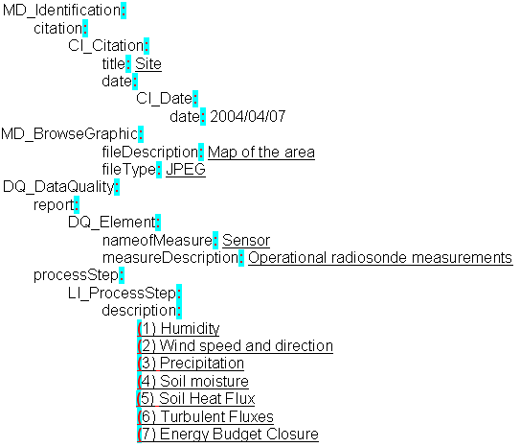

FIGURE 5: example of metadata schema from the Committee on Earth Observation Satellites (CEOS) / Working Group on Information Systems Services (WGISS) / WGISS Test Facility for Coordinated Enhanced Observing Period (WTF-CEOP).

